**57th Regiment NZ Wars Memorial**

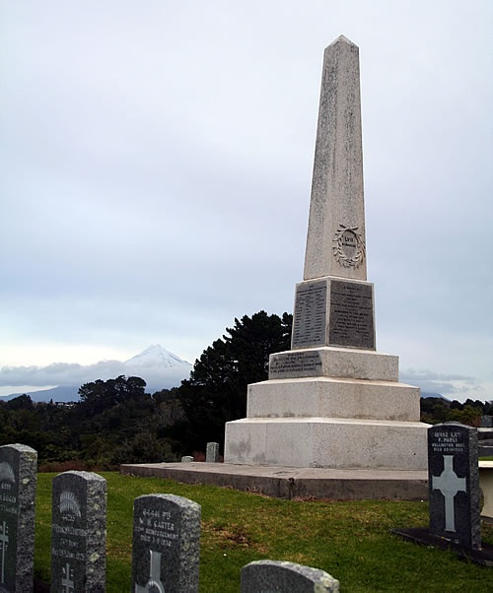

This obelisk is located in New Plymouth's Te Henui Cemetery, commemorating the soldiers of the 57th Middlesex Regiment. Battles erupted in 1860 between settlers and Maori over a territorial dispute; and the 57th, known throughout the British service as the "Die Hards," arrived in 1861 to reinforce local conscripts. A London stonemason provided the monument, which the townspeople erected to commemorate the Die Hards who perished in battle or succumbed to disease.